Current Operable Unit 3 Remedial Progress for Phase II Week Ending 4/30/10
Creamer Environmental Inc., National Grid’s Remediation Contractor, has started and will continue to relocate field operations to the north-side of the site where the LIRR tracks were relocated back to their original location. The mobilization includes bringing construction equipment, materials, and temporary facilities to the site. Creamer has also finished construction on the Temporary Fabric Structure (TFS) and will continue to install security fence around the perimeter of the work area. Phase 2 Sheet pile installation will start Monday May 3rd and will continue for the next few weeks.
GEI, National Grid’s Remediation Oversight Consultant, will continue to perform CAMP (Community Air Monitoring Program), Noise and Vibration monitoring. CAMP, Noise and Vibration monitoring will continue throughout the project.

Two-Week Outlook
Creamer Environmental Inc. is expected to complete mobilization of equipment, materials, and temporary facilities including mobilization and set-up of the Temporary Fabric Structure (TFS) by week ending 5/7/10. Phase 2 sheet pile installation will continue throughout the next few weeks followed by limited excavation to install a bracing system along the sheet line.
General hours of operation will continue to be Monday through Friday, 7:00 AM to 3:30 PM. However, work hours will be extended when necessary to maintain schedule or to complete critical tasks.

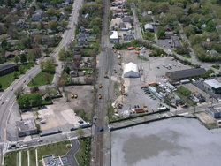
LIRR moving tracks back to original location
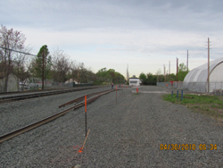
RFC installing new security fence along Ramp_R line

